Have we hit a soft spot, or has the bounce run its course?
Still looking to me a lot more line an L shaped recovery than the traditional V shaped recovery:

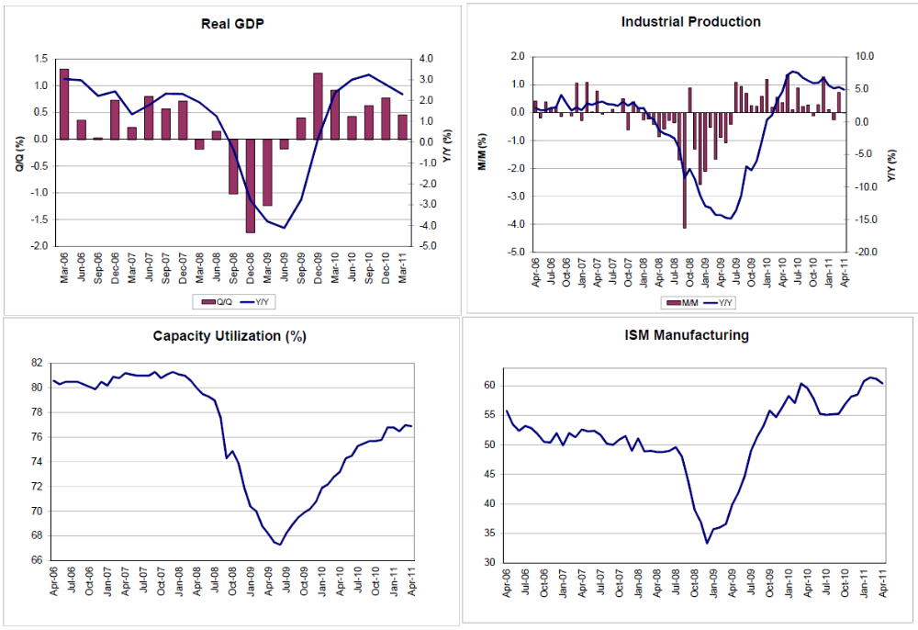
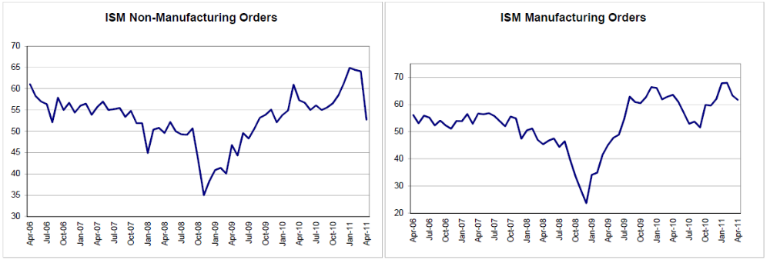
With Q2 GDP estimates now a lot closer to 2% than the 4% originally forecast it’s starting to look more like the post recession bounce/inventory rebuilding has about run its course, and we are settling in at very modest growth levels. And with low demand in the UK and the euro zone due to their austerity measures, China fighting inflation, along with India and Brazil, Japan looking like they are dragging their feet with any kind of rebuilding program, and considering tax hikes to pay for what they might do, the US with a political consensus to cut $4-6 trillion from the federal deficit, little if any sign of a meaningful private sector credit expansion, and very modest gains in real incomes even with the latest employment gains, I don’t see any forces at work that could close our massive output gap anytime soon.
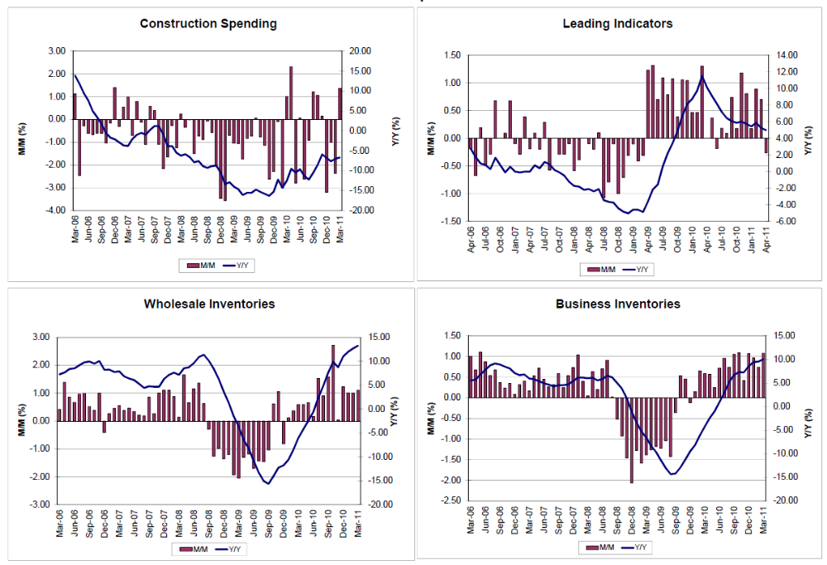
Construction remains near 0 for all practical purposes, and leading indicators are in line with what inventories look like- the rebuilding from the lows may have run its course.
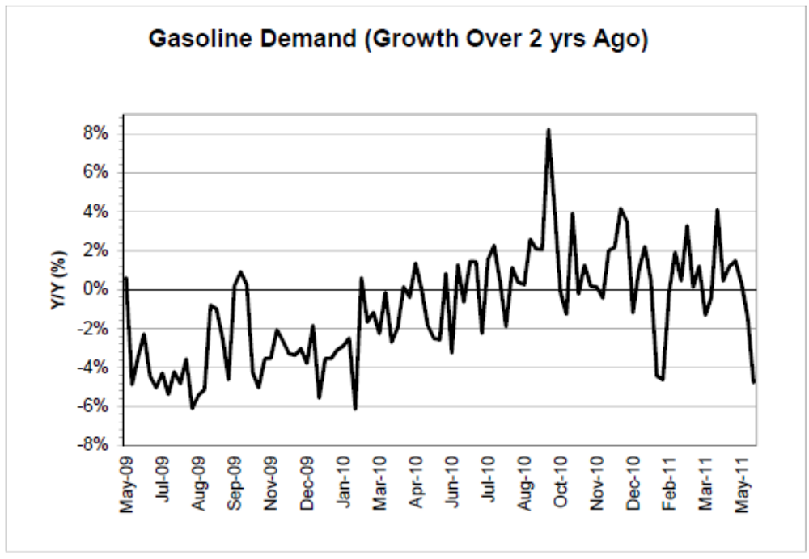
It’s interesting that we’ve had as much GDP growth as we’ve had, without the usual growth in gasoline consumption. I still expect a supply response in the form of alternative fuels for transportation to reduce US consumption of crude and products, but it will take a while.
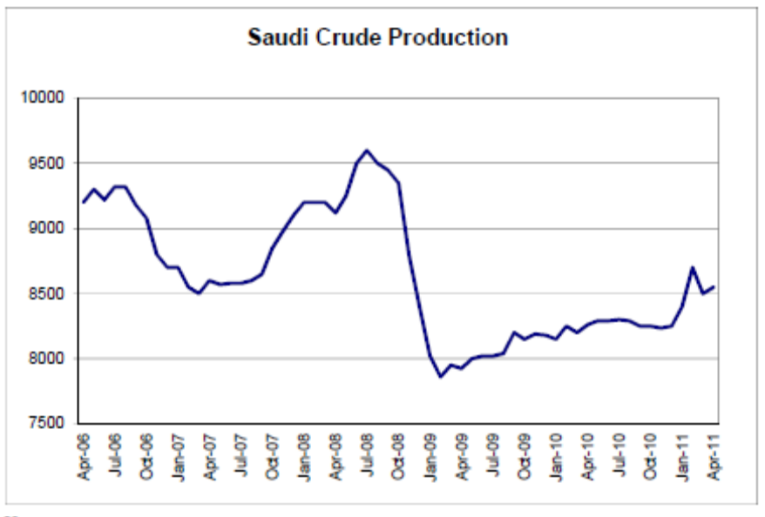
Nor does demand for Saudi crude show there’s been much change in the total global supply/demand balance, even with supply cuts in Lybia. In fact, it wouldn’t surprise me to see demand for Saudi crude fall back through the 8 million bpd level over the rest of this year.
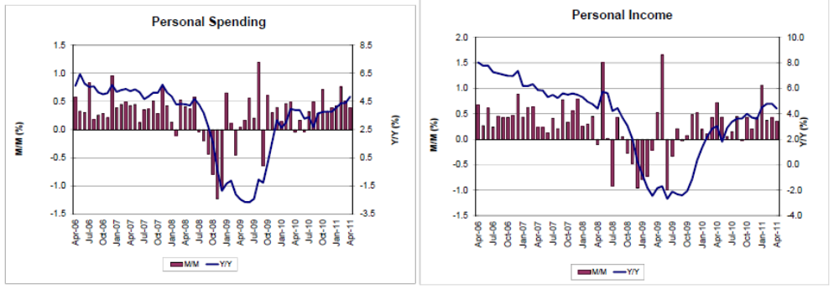
Neither is growing at pre crisis rates, with personal income is being held down by reduced interest income in addition to high unemployment and downward pressures on compensation.
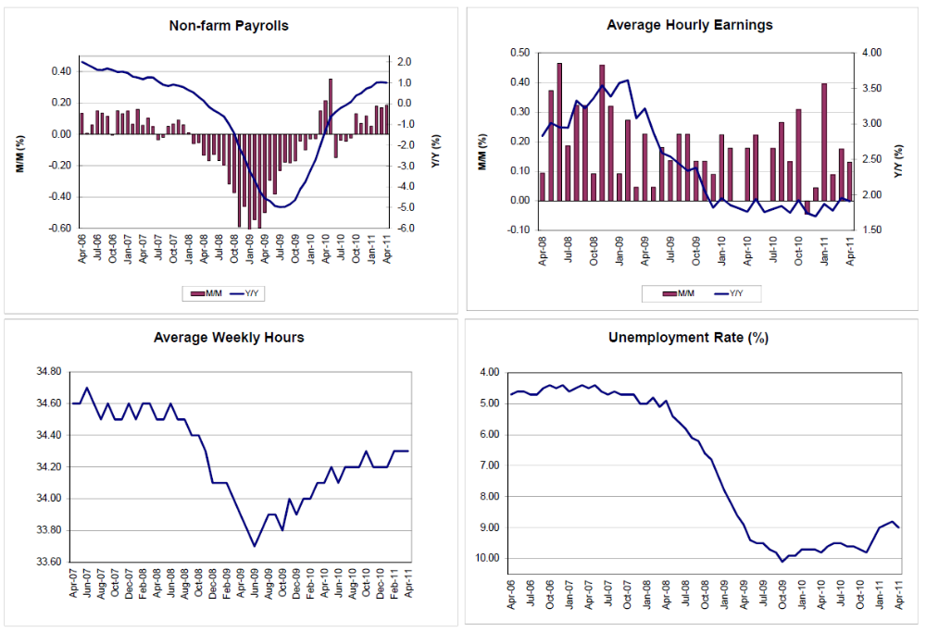
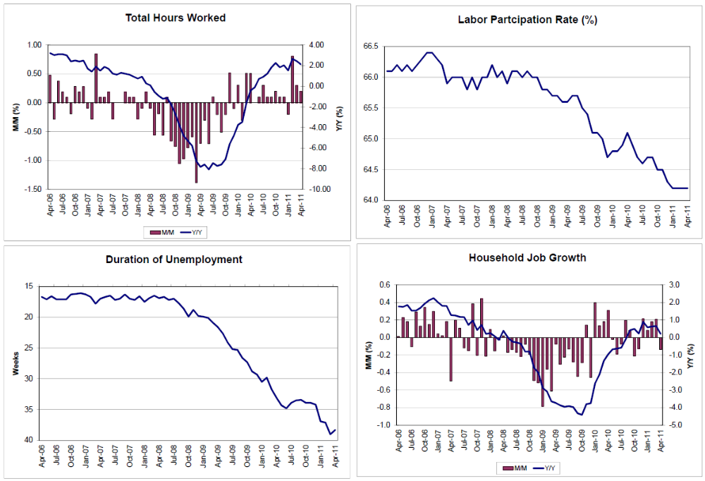
The last monthly employment report was deemed a positive, with bond markets moving higher in yield as the odds of a Fed rate hike elevated. But I didn’t read it that way and still don’t. In fact, it looks dismal to me, and the interim numbers now have analysts reducing their estimates for payrolls in Friday’s report to the 150,000 range.
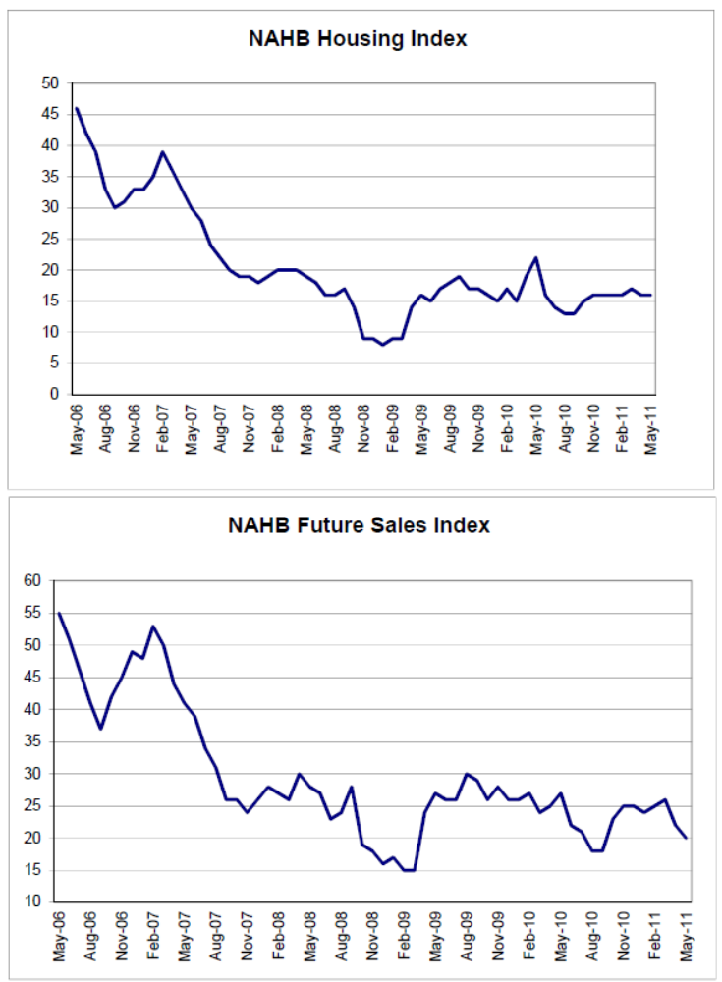
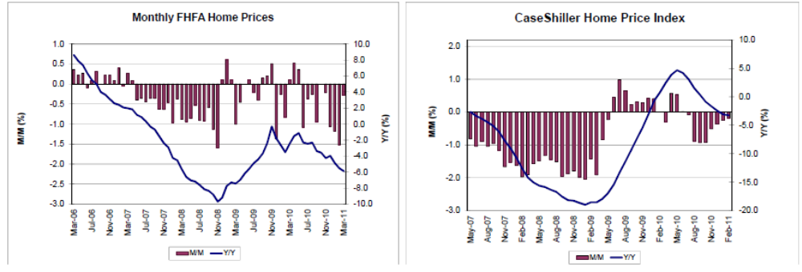
All the housing indicators look grim.
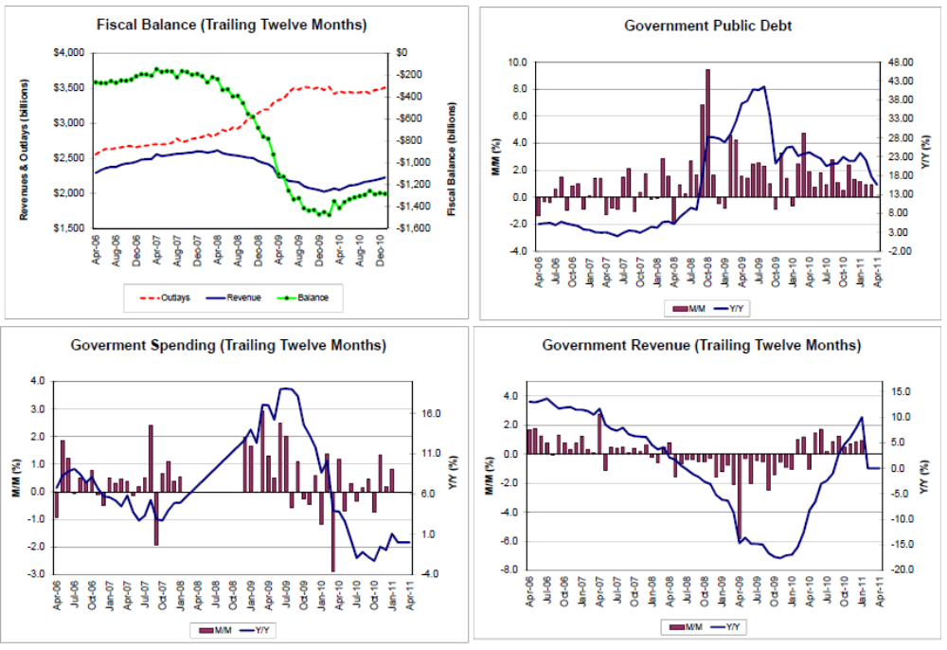
Govt spending seems to be trailing off and revenue growth is extremely modest for this part of this cycle, even adjusting for the year end FICA cut/work for pay expiration combo that reduced taxes a tad. Because work for pay likely had a higher multiple than FICA, the adjustment was probably pretty close to neutral with regards to aggregate demand, and may have even reduced it some. Additionally, the $38 billion in spending cuts last month will keep the growth of govt spending below what it would have been otherwise, and the serious cuts are presumably on track to be passed by the Aug. 2 debt ceiling ‘crisis’ vote. (and not to mention the continuing QE tax that removed the interest on the $3 trillion or so securities the economy would have earned if the Fed hadn’t bought them)
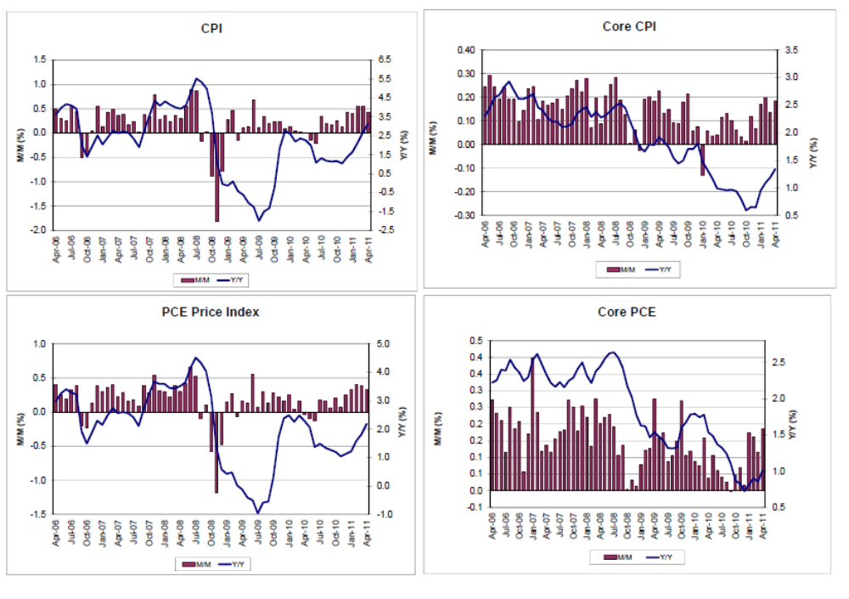
Fed Chairman Bernanke knows the difference between prices rising to express relative value in a market economy and ‘inflation’ and recognizes these numbers remain very weak. He also sees the threat as asymmetrical, with, the way he sees it, deflation a lot more problematic than inflation.
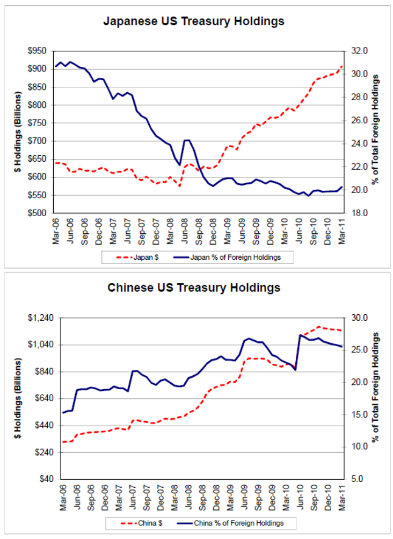
So who’s buying $US and adding to their reserves?
Looks like Japan, and not China.
In fact, reads like China may be selling?
To support their currency to fight inflation, at the expense of their sacred exporters?
Treasury holdings, however, are only part of the picture, so don’t read too much into this alone.
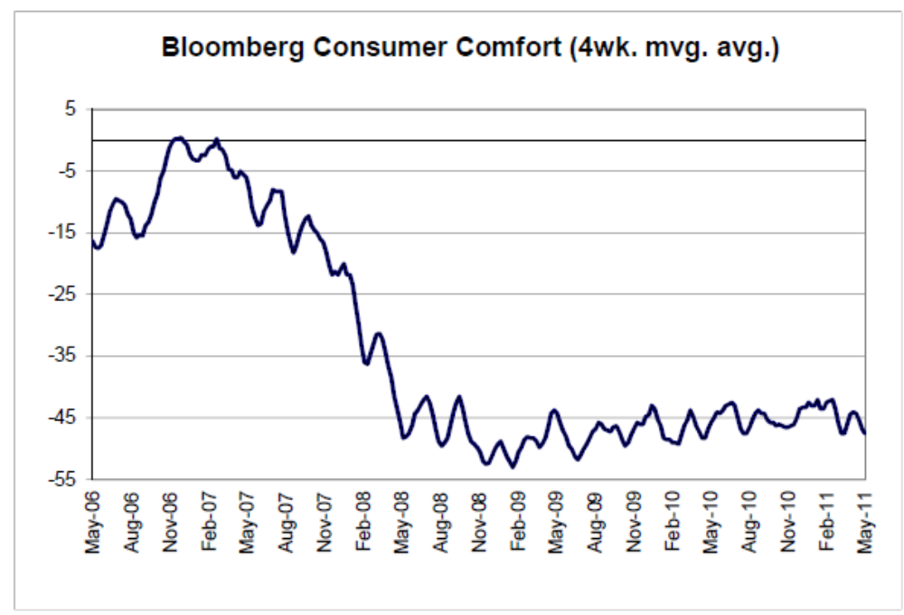
All of these types of surveys pretty much look like this one.
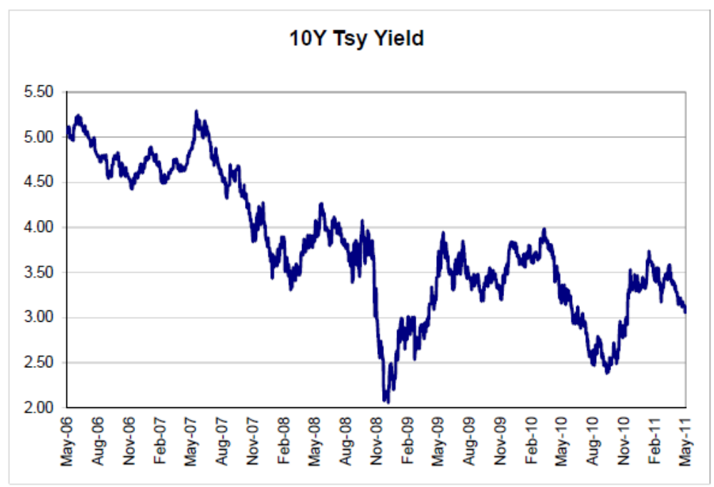
No spike in rates here? Looking more like what happened in Japan?
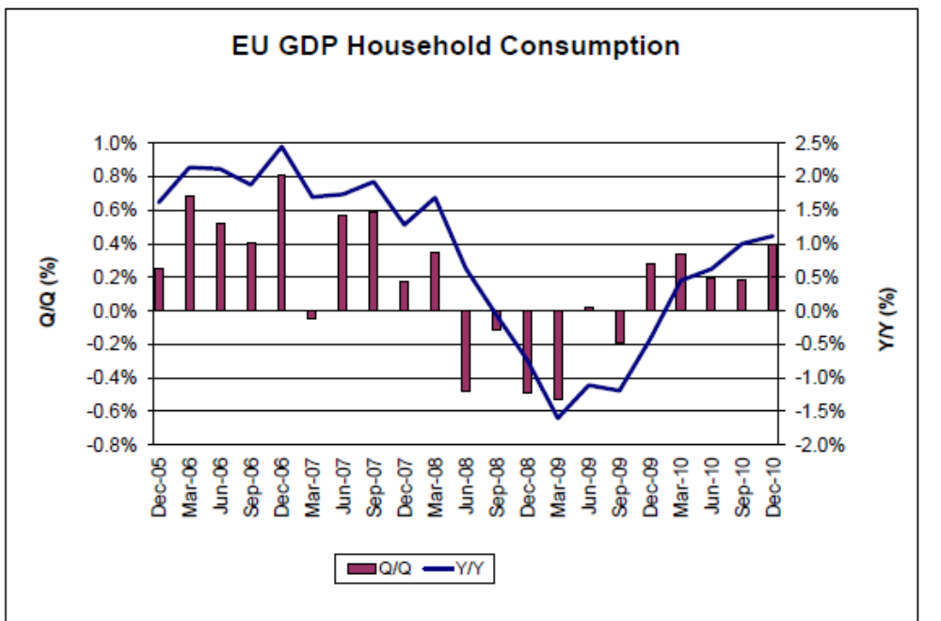
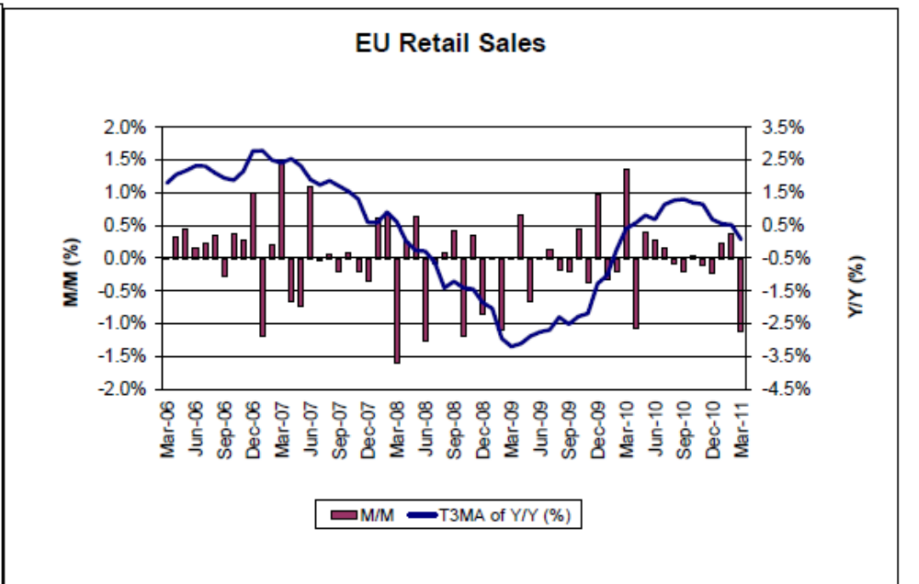

Consumption never had been their strong point.

